**Import the EPAS SharePoint Site**

1. Copy the files to C:\epasimport ( note: create new folder)
2. Go to **Start** menu, click **All Programs**, click **Microsoft SharePoint 2013 Products**, and then click **SharePoint 2013 Management Shell** and run the below command

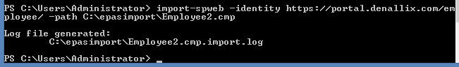

Note: The SharePoint library permission should be migrated with the import. If you’re manually creating the library, be sure to stop the permission inheritance and grant only administrator an Human Resources with full control.

Also, make sure K2 for SharePoint is up to date. If not update it and run the Registration Wizard